# CA 1

727721euit043

GURU VISHNU S

Mandatory part that to be present in the Project Code

1. Open the relevant website and maximize browser window.
2. Print its Page title.
3. Validate Page Title

Problem Statement 1

An e-commerce website that allows users to search and purchase products online. Design a test suite to test the checkout functionality using Selenium. Consider different test scenarios such as adding products to the cart, searching product, and selecting payment methods.

Question 1

1. Verify that the user can add a product to the cart by clicking on the "Add to Cart" button on the product page.

import org.openqa.selenium.By;

import org.openqa.selenium.WebDriver;

import org.openqa.selenium.WebElement;

import org.openqa.selenium.chrome.ChromeDriver;

import org.openqa.selenium.chrome.ChromeOptions;

import io.github.bonigarcia.wdm.WebDriverManager;

public class ca1q2 {

public static void main( String[] args ) throws InterruptedException

{

WebDriverManager.chromedriver().setup();

ChromeOptions co=new ChromeOptions();

co.addArguments("--remote-allow-origins=\*");

WebDriver driver=new ChromeDriver(co);

driver.manage().window().maximize();

driver.get("https://www.amazon.in/iQOO-Dimensity-Processor-Brightest-FlashCharge/dp/B07WFPMQB1/?\_encoding=UTF8&\_ref=dlx\_gate\_sd\_dcl\_tlt\_930e4f44\_dt&pd\_rd\_w=uqT70&content-id=amzn1.sym.a532052b-26f3-4811-a261-3b35ffa57237&pf\_rd\_p=a532052b-26f3-4811-a261-3b35ffa57237&pf\_rd\_r=9J49W4FE81JVE39AP30G&pd\_rd\_wg=XtbWR&pd\_rd\_r=4a08dee9-c133-4c81-9452-d1f9cb5a7498&ref\_=pd\_gw\_unk&th=1");

driver.findElement(By.id("add-to-cart-button")).submit();

}

}

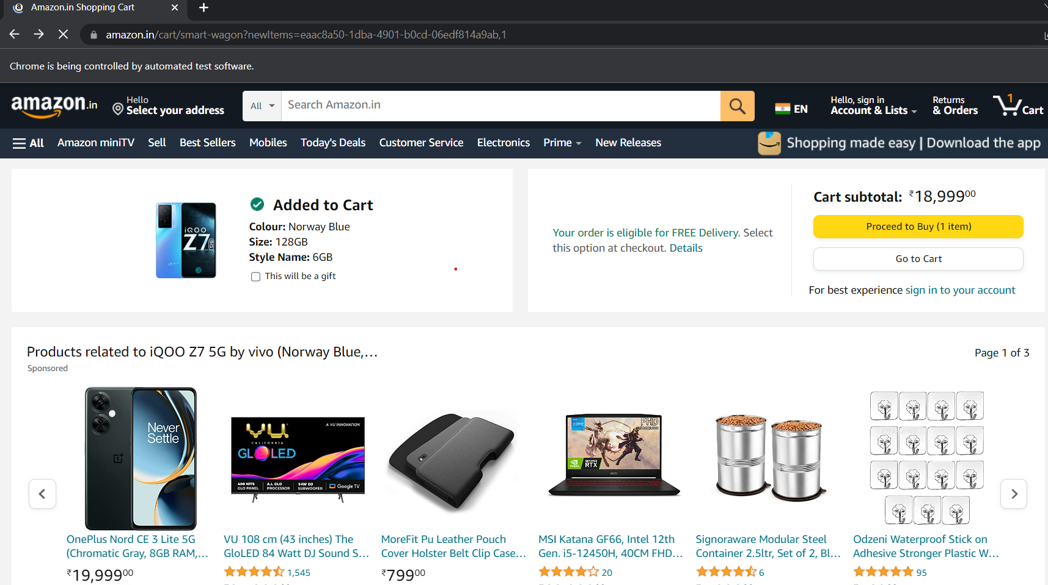

2. Verify that the user can remove a product from the cart by clicking on the "Remove" button next to the product.

package com.selenium.test2.selenium1;

import org.openqa.selenium.By;

import org.openqa.selenium.WebDriver;

import org.openqa.selenium.WebElement;

import org.openqa.selenium.chrome.ChromeDriver;

import org.openqa.selenium.chrome.ChromeOptions;

import io.github.bonigarcia.wdm.WebDriverManager;

public class ca1q2 {

public static void main( String[] args ) throws InterruptedException

{

WebDriverManager.chromedriver().setup();

ChromeOptions co=new ChromeOptions();

co.addArguments("--remote-allow-origins=\*");

WebDriver driver=new ChromeDriver(co);

driver.manage().window().maximize();

driver.get("https://www.amazon.in/iQOO-Dimensity-Processor-Brightest-FlashCharge/dp/B07WFPMQB1/?\_encoding=UTF8&\_ref=dlx\_gate\_sd\_dcl\_tlt\_930e4f44\_dt&pd\_rd\_w=uqT70&content-id=amzn1.sym.a532052b-26f3-4811-a261-3b35ffa57237&pf\_rd\_p=a532052b-26f3-4811-a261-3b35ffa57237&pf\_rd\_r=9J49W4FE81JVE39AP30G&pd\_rd\_wg=XtbWR&pd\_rd\_r=4a08dee9-c133-4c81-9452-d1f9cb5a7498&ref\_=pd\_gw\_unk&th=1");

driver.findElement(By.id("add-to-cart-button")).submit();

driver.get("https://www.amazon.in/gp/cart/view.html?ref\_=nav\_cart");

driver.findElement(By.cssSelector("[value='Delete']")).click();

String t=driver.getTitle();

System.out.println(t);

}

}

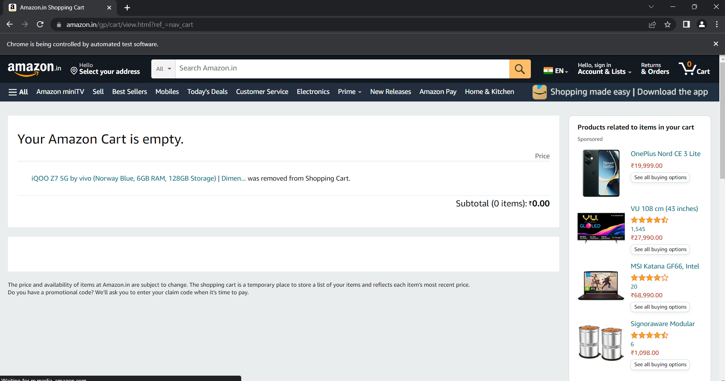

3.Verify that the user can update the quantity of a product in the cart by changing the quantity and clicking on the "Update" buttonCode:

package com.Selenium.Test.selenium1;  
  
import java.util.List;  
  
import [org.openqa.selenium.By](http://org.openqa.selenium.by/" \t "_blank);  
import org.openqa.selenium.JavascriptExecutor;  
import org.openqa.selenium.WebDriver;  
import org.openqa.selenium.WebElement;  
import org.openqa.selenium.chrome.ChromeDriver;  
import org.openqa.selenium.chrome.ChromeOptions;  
import org.openqa.selenium.edge.EdgeDriver;  
import org.openqa.selenium.interactions.Actions;  
import org.openqa.selenium.support.ui.Select;  
  
import dev.failsafe.internal.util.Assert;  
import io.github.bonigarcia.wdm.WebDriverManager;  
public class Q1 {  
    public static void main( String[] args ) throws InterruptedException  
    {  
           WebDriverManager.chromedriver().setup();  
        ChromeOptions co=new ChromeOptions();  
        co.addArguments("--remote-allow-origins=\*");  
        WebDriver driver=new ChromeDriver(co);  
        driver.manage().window().maximize();  
        driver.get(https://www.amazon.in/Noise-Launched-Bluetooth-Calling-Tracking/dp/B0BJ72WZQ7/ref=sr\_1\_2?pd\_rd\_r=a7a5a670-875b-4af9-a747-1b6158340243&pd\_rd\_w=i7UOP&pd\_rd\_wg=boSxr&pf\_rd\_p=3a59b28c-4626-48f9-b66f-114571ee563d&pf\_rd\_r=JHCWBQZ71SBBASFRXXK3&qid=1681292072&sr=8-2&th=1#");  
        driver.findElement(By.id("add-to-cart-button")).submit();  
        String t=driver.getTitle();  
        System.out.println(t);  
         
         
        String cart=driver.findElement(By.xpath("//\*[@id=\"NATC\_SMART\_WAGON\_CONF\_MSG\_SUCCESS\"]/span")).getText();  
        if(cart.equals("Added to cart"));  
        System.out.println("1.  Verified that Product added to cart ");  
         
        driver.navigate().back();  
             
            WebElement sort1=driver.findElement(By.xpath("//\*[@id=\"quantity\"]"));  
                sort1.click();  
                Select select=new Select(sort1);  
                select.selectByIndex(1);  
                 
                String drop=driver.findElement(By.xpath("//\*[@id=\"quantity\"]")).getText();  
            if(drop.equals("2"));  
            System.out.println("3.  Verified that Product is updated to cart ");  
    }  
}

output:  
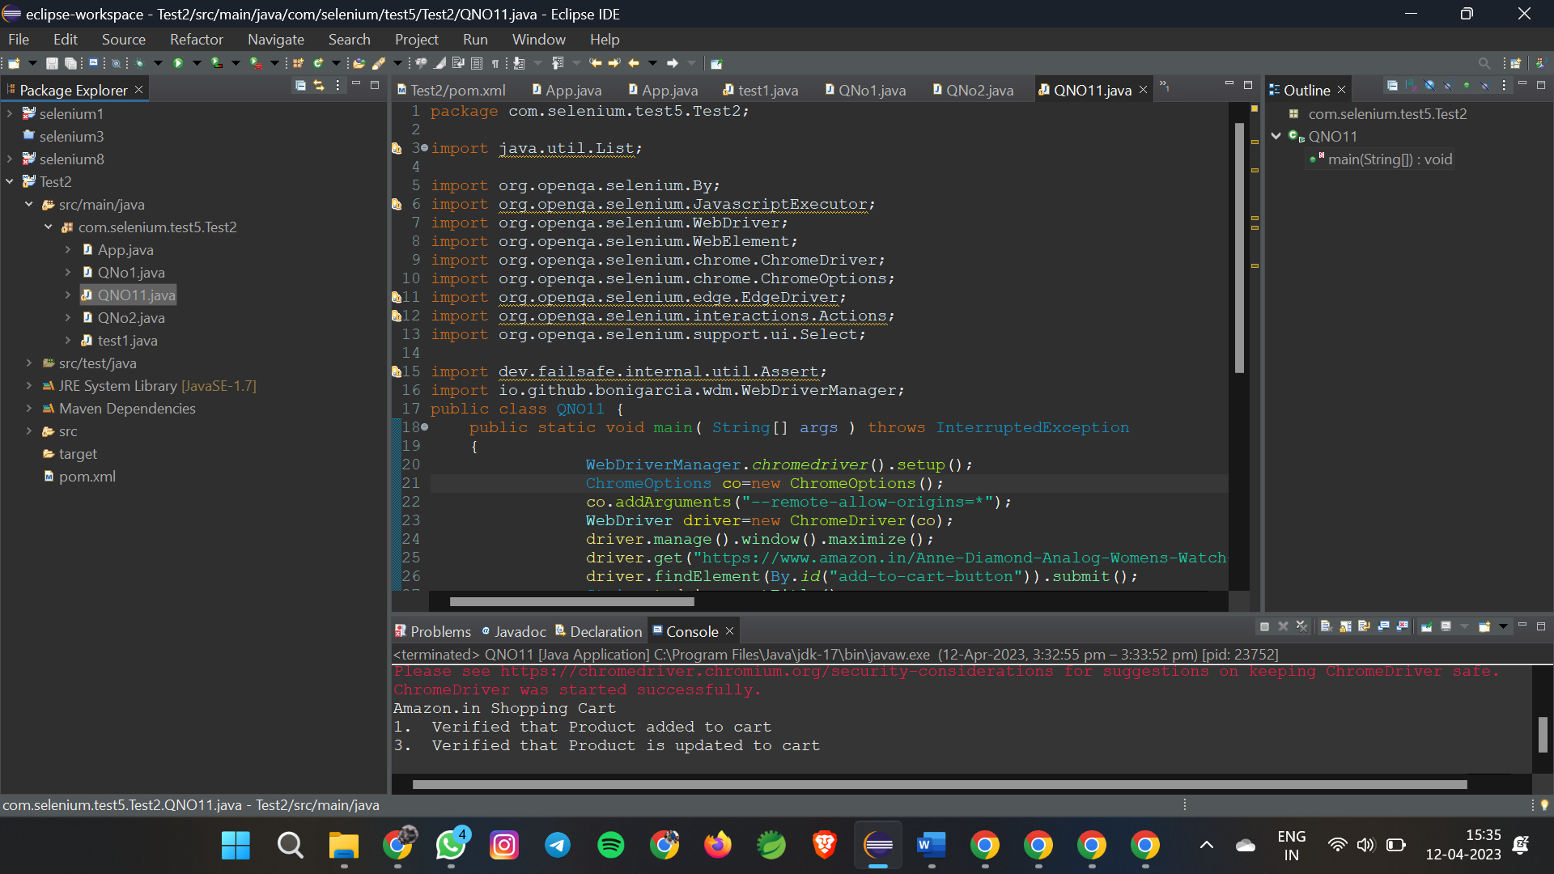

2.

1. Verify that the user can search any product on website and the corresponding search product details needs to be displayed

Code:

package com.selenium.test5.Test2;

import org.openqa.selenium.By;

import org.openqa.selenium.Keys;

import org.openqa.selenium.WebDriver;

import org.openqa.selenium.WebElement;

import org.openqa.selenium.chrome.ChromeDriver;

import org.openqa.selenium.chrome.ChromeOptions;

import io.github.bonigarcia.wdm.WebDriverManager;

public class QNO21 {

public static void main( String[] args ) throws InterruptedException

{

WebDriverManager.chromedriver().setup();

ChromeOptions co=new ChromeOptions();

co.addArguments("--remote-allow-origins=\*");

WebDriver driver=new ChromeDriver(co);

driver.get("https://www.amazon.in/");

driver.manage().window().maximize();

String actualTitle=driver.getTitle();

System.out.println("Page title is : " + driver.getTitle());

String expectedTitle = "Online Shopping site in India: Shop Online for Mobiles, Books, Watches, Shoes and More - Amazon.in";

if(actualTitle.equalsIgnoreCase(expectedTitle))

System.out.println("Title Matched");

else

System.out.println("Title didn't match");

WebElement txt1=driver.findElement(By.id("twotabsearchtextbox"));

txt1.sendKeys("LAPTOP");

driver.findElement(By.id("twotabsearchtextbox")).sendKeys(Keys.ENTER);

}

}

Output:

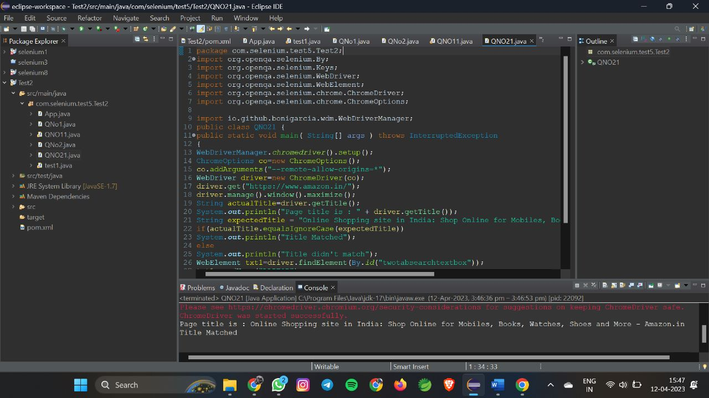

2

Print minimum 5 Names of the products displayed on the webpage

package com.Selenium.test1;  
  
import java.util.List;  
  
import [org.openqa.selenium.By](http://org.openqa.selenium.by/" \t "_blank);  
import org.openqa.selenium.JavascriptExecutor;  
import org.openqa.selenium.WebDriver;  
import org.openqa.selenium.WebElement;  
import org.openqa.selenium.chrome.ChromeDriver;  
import org.openqa.selenium.chrome.ChromeOptions;  
  
import io.github.bonigarcia.wdm.WebDriverManager;  
  
public class QNo2 {  
   
public static void main(String args[]) {  
WebDriverManager.chromedriver().setup();  
ChromeOptions co=new ChromeOptions();  
co.addArguments("--remote-allow-origins=\*");  
WebDriver driver=new ChromeDriver(co);  
driver.get("[https://www.amazon.in/deal/2c2d3a50/?\_encoding=UTF8&showVariations=true&\_ref=dlx\_gate\_sd\_dcl\_tlt\_2c2d3a50\_dt&pd\_rd\_w=YgMyt&content-id=amzn1.sym.a532052b-26f3-4811-a261-3b35ffa57237&pf\_rd\_p=a532052b-26f3-4811-a261-3b35ffa57237&pf\_rd\_r=SWJFXC5PAM03PF4G0AWT&pd\_rd\_wg=6zviy&pd\_rd\_r=1f436e7b-ab36-4c27-9e50-8f8c69db422a&ref\_=pd\_gw\_unk](https://www.amazon.in/deal/2c2d3a50/?_encoding=UTF8&showVariations=true&_ref=dlx_gate_sd_dcl_tlt_2c2d3a50_dt&pd_rd_w=YgMyt&content-id=amzn1.sym.a532052b-26f3-4811-a261-3b35ffa57237&pf_rd_p=a532052b-26f3-4811-a261-3b35ffa57237&pf_rd_r=SWJFXC5PAM03PF4G0AWT&pd_rd_wg=6zviy&pd_rd_r=1f436e7b-ab36-4c27-9e50-8f8c69db422a&ref_=pd_gw_unk" \t "_blank)");  
driver.manage().window().maximize();  
  
JavascriptExecutor js=(JavascriptExecutor) driver;  
js.executeScript("window.scrollBy(0,1000)","");  
  
String title = driver.getTitle();  
System.out.println(title);  
String title2="Budget Laptops under INR 45000; Mega Electronic Days";  
//title2=driver.getTitle();  
if(title2.equals(title)) {  
System.out.println("It is corret page title");  
}  
  
List<WebElement> li=driver.findElements(By.xpath("//\*[@id=\"octopus-dlp-asin-stream\"]/ul/li[3]/span/div/div[2]/div[1]/a"]"));"  
for(WebElement link:li) {  
System.out.println(link.getText());  
}  
  
driver.navigate().back();  
driver.navigate().forward();  
driver.navigate().refresh();  
driver.quit();  
  
}  
}

Output:

